|  |
| --- |
| genweb2 ltd. |
| Samuda HR User Manager User Manual |
| REFERENCE: GW/ERP/USER MANUAL |
|  |
| **Genweb2 Ltd.** |
| **09-May-17** |

|  |
| --- |
| logo.png  **Genweb2 Limited**  TK Bhaban (11th Floor),  13 KaziNazrul Islam Avenue,  Kawran Bazar, Dhaka 1215, Bangladesh  web: [http://www.genweb2.com](http://www.genweb2.com/) |

Contents

1. User Management 2

1.1 Create Users 2

# 1. User Management

User Management is an authentication feature that provides administrators with the ability to identify and control the state of users logged into the network. This includes, but is not limited to, the ability to query and filter users that are currently logged into the network, manually log out users, and control user login counts and login times.

## 1.1 Create Users

First we need to create a user. From the Settings module, go to the submenu users ‣ users and click on create. First add the name of your new user and the professional email address - the one he will use to log into - and a picture.

Using the menu **Settings ‣ Users ‣ Users** and click **Create.** Department manager/ HR manager can create a User.

You need to configure the following:-

**Name**: A name for the user.

**Email Address:** An email address for the user login.

**Password:** A password for user login.

**Allowed Companies:** Select employee’s company name.

**Current Company:** Select employee’s current company name.

**Default Operating Unit:** Add a default operating unit.

**Operating Units:** Add default operating units.

After entering the user information click **Save**.

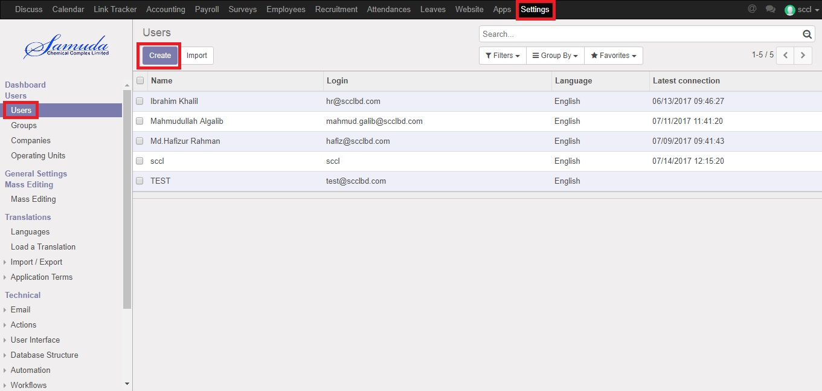

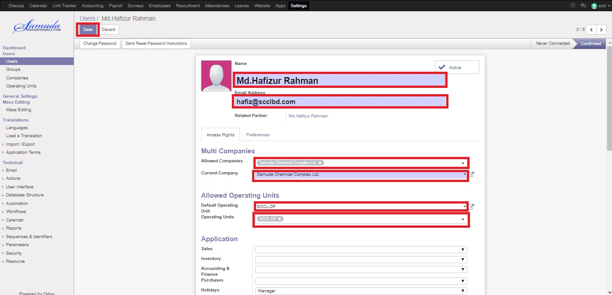

Figure: Create a User

**Change user password and click Save**

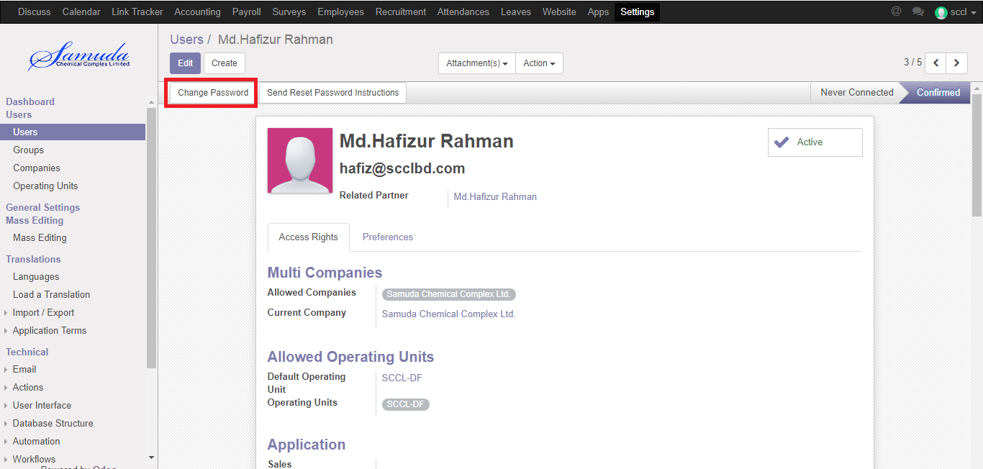

After clicking **Change Password** button then add new password and click **Change Password** button.

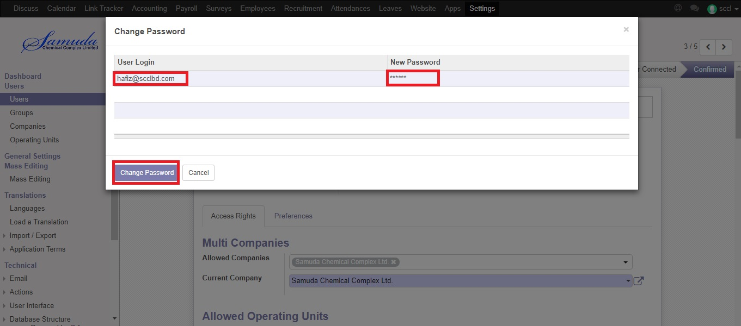

Fig: Change Password

**Edit User and click Save**

For edit user click **Edit** button then change what do you want and click **Save**.

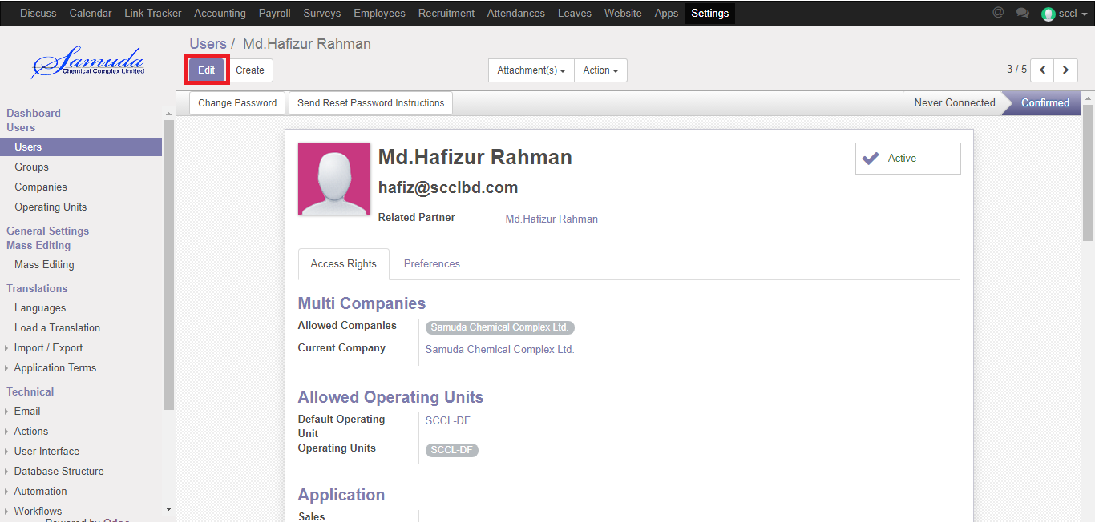

When you’re done editing the page and have clicked on SAVE, an invitation email will automatically be sent to the user. The user must click on it to accept the invitation to your instance and create a log-in.